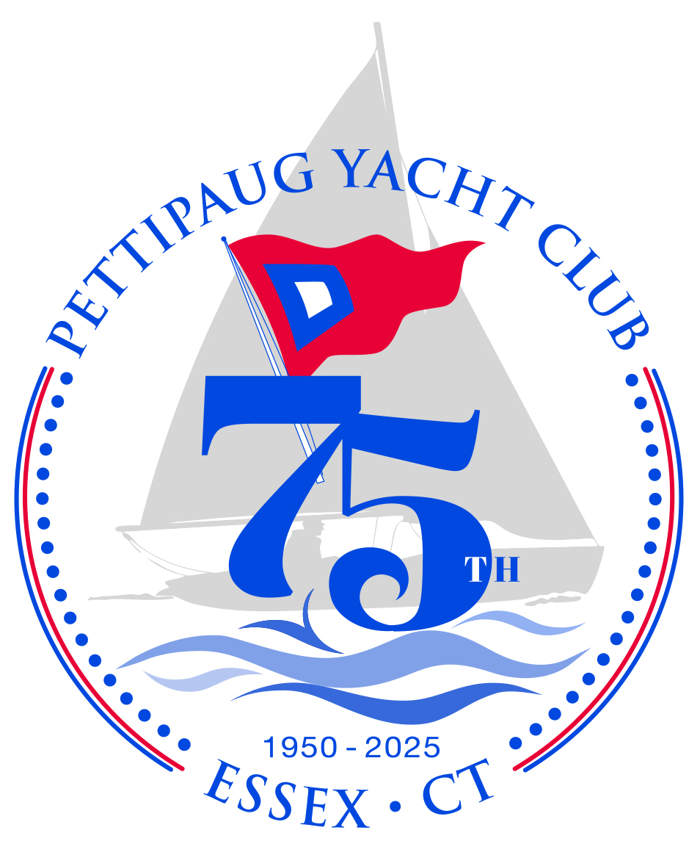COMMODORE’S COMMENTS
April- HAPPY MAY DAY!

The weather has not been cooperative for our work parties but that didn’t hinder many
members from coming and doing what could be done on the deck, in the yard and cleaning
the boats. A new split- rail fence has been installed, areas painted and many more “to be painted” await an enthusiast with a brush. Planting, mowing, trimming and weeding
are also on the TO-DO list. Two new ladders will be installed on the docks, Essex Boat Club will be maintaining the road this season, we are waiting for the gravel to fill the large holes
in the boat yard so members may bring their boats to PYC...soon! If you have a free morning or afternoon and would like to lend a hand, please contact me and I will meet you at PYC. May 24th and 25th is the celebratory weekend for PYC’s 75th Anniversary, Commodore’s Race
and Commissioning. We’re getting PYC in shape to welcome all members, alumni and
guests! commodore@pettipaug.org Your invitation will be in your email tomorrow.

Many thanks and appreciation for all of you who in spite of the rain and chill, sent hours
of effort these past two weekends. And kudos, to Coach Mark Kondraky’s High School kids who ambitiously moved and schlepped many picnic tables, water-soaked logs, grills etc.

HOLA~ MONDAY, MAY 5th CINCO DE MAYO! Stop by PYC, bring a dish to share, have a marguerita or BYOB. sign the new “simple” boat owner form and pick-up your 2025 STICKER! 5 p.m. Senorita -Joanna will be on hand to help.

PYC PRIVATE PARTY MEMBERSHIP AGREEMENT~ Gather by the river! Click here to access directly. Please contact me with any questions, dates you would like to use the club or comments that you have. Contact: commodore@pettipaug.org The donations from these
reservations offset supplies, dumpsters, building maintenance, etc. Thank you!

PETTIPAUG SAFE POWER BOATING COURSE: GREAT GIFT for mom, dad of grad!
Two-day hands-on Power Boat Operator course (Saturday and Sunday):
DATES: May 17/18, June 14/15, August 9/10
Sign up to learn and improve your powerboat skills! The course covers the requirements to earn a Connecticut Certificate of Personal Watercraft Operation (CPWO) provides hands-on power boat training. It is one of the few hands-on courses available in Connecticut. Click here for full details. Questions- please reach out to Bob Cashman: pbc@pettipaug.org

THE SHIP’S STORE
Pettipaug is offering 75 th logo long sleeve T’ shirts for sale this summer. Available:
are a unisex shirt, sizes small to xl and a women’s round neck shirt, sizes xs to xl.
The anniversary logo will be on the front and “Pettipaug Yacht Club” will be on the back.
We are taking preorders now. ORDER NOW~ Price is $25 and shirts will be available for pick up at Pettipaug during Commissioning weekend. Email Alison at shipstore@pettipaug.org with your name, style (unisex or women’s) and size to place your order.
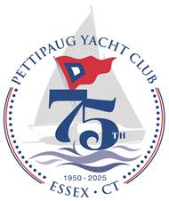

SPRING- SUMMER-FALL SAILING at PYC
Pettipaug offers great opportunities to grab your boat and get out and sail. The camaraderie, the acquired skills learned from time on the water and shared experiences promote great sailing times at PYC. Here is the contact information for sailing groups:
BLUE JAY SERIES contact: probinson02@snet.net. Wednesdays once a month
MC SCOWS contact: Amy Walsh mcfleet99@gmail.com.Tuesday Evenings
SUNFISH & all FLEETS contact: Sarah DuBois sarahsails1@gamil.com. Thursday Evenings
All welcomed! Not a sailor? PYC is always in need of those interested in helping with Race Committee. Please reach out to Dick Hutchinson:

WOMEN ON THE RIVER
Note that the 3 dinners at EYC are $30 including tax and tip, same as last year.
Women on the River (WOR) is back for another exciting season! WOR brings together enthusiastic women sailors of all levels from five local clubs along the CT River: Pettipaug Yacht Club, Essex Corinthian Yacht Club, Essex Yacht Club, Hamburg Cove Yacht Club, and North Cove Yacht Club. All dates are Wednesdays at 5 pm sharp and we meet rain or shine.
- May 21 – Sail & Potluck at ECYC. No fee. Bring a dish to share.
- May 28 – Sail & Dinner at EYC. $30 for dinner (includes tax and tip).
Note: PYC Blue Jay Series on same date.
- June 4 – Sail & Dinner at EYC. $30 for dinner (includes tax and tip)
- June 11 – Sail & Dinner at EYC. $30 for dinner (includes tax and tip)
If you're interested in joining this fun and empowering group, please email by May 5
Contact: Marilou Griswold 860-227-3638 marilougriswold@comcast.net

APRIL TRIVIA QUESTION:
Who am I?
