PYC Reclaimed Kayaks
3-17-19
Revised 3-26-19

Wilderness Systems Cape Horn Kayak with rudder. 15ft. Yellow $350 (sold)
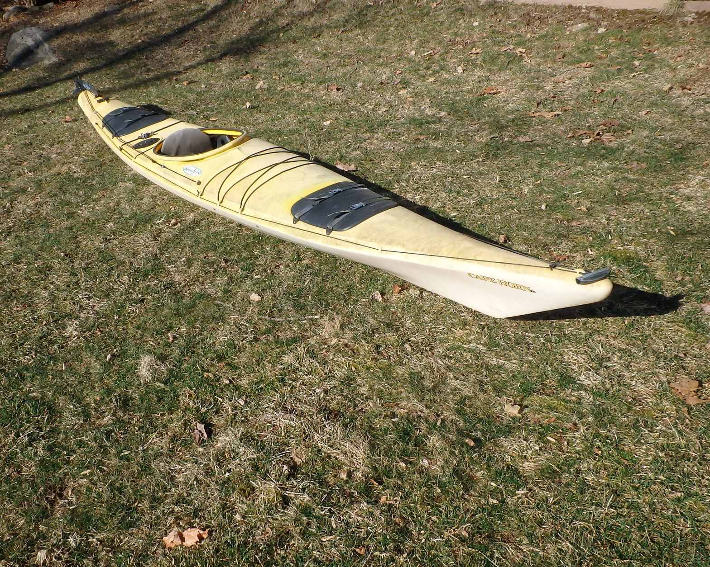

Dimension Typhoon Sit-on-Top Kayak. 11ft. Yellow $200 (new price $100)

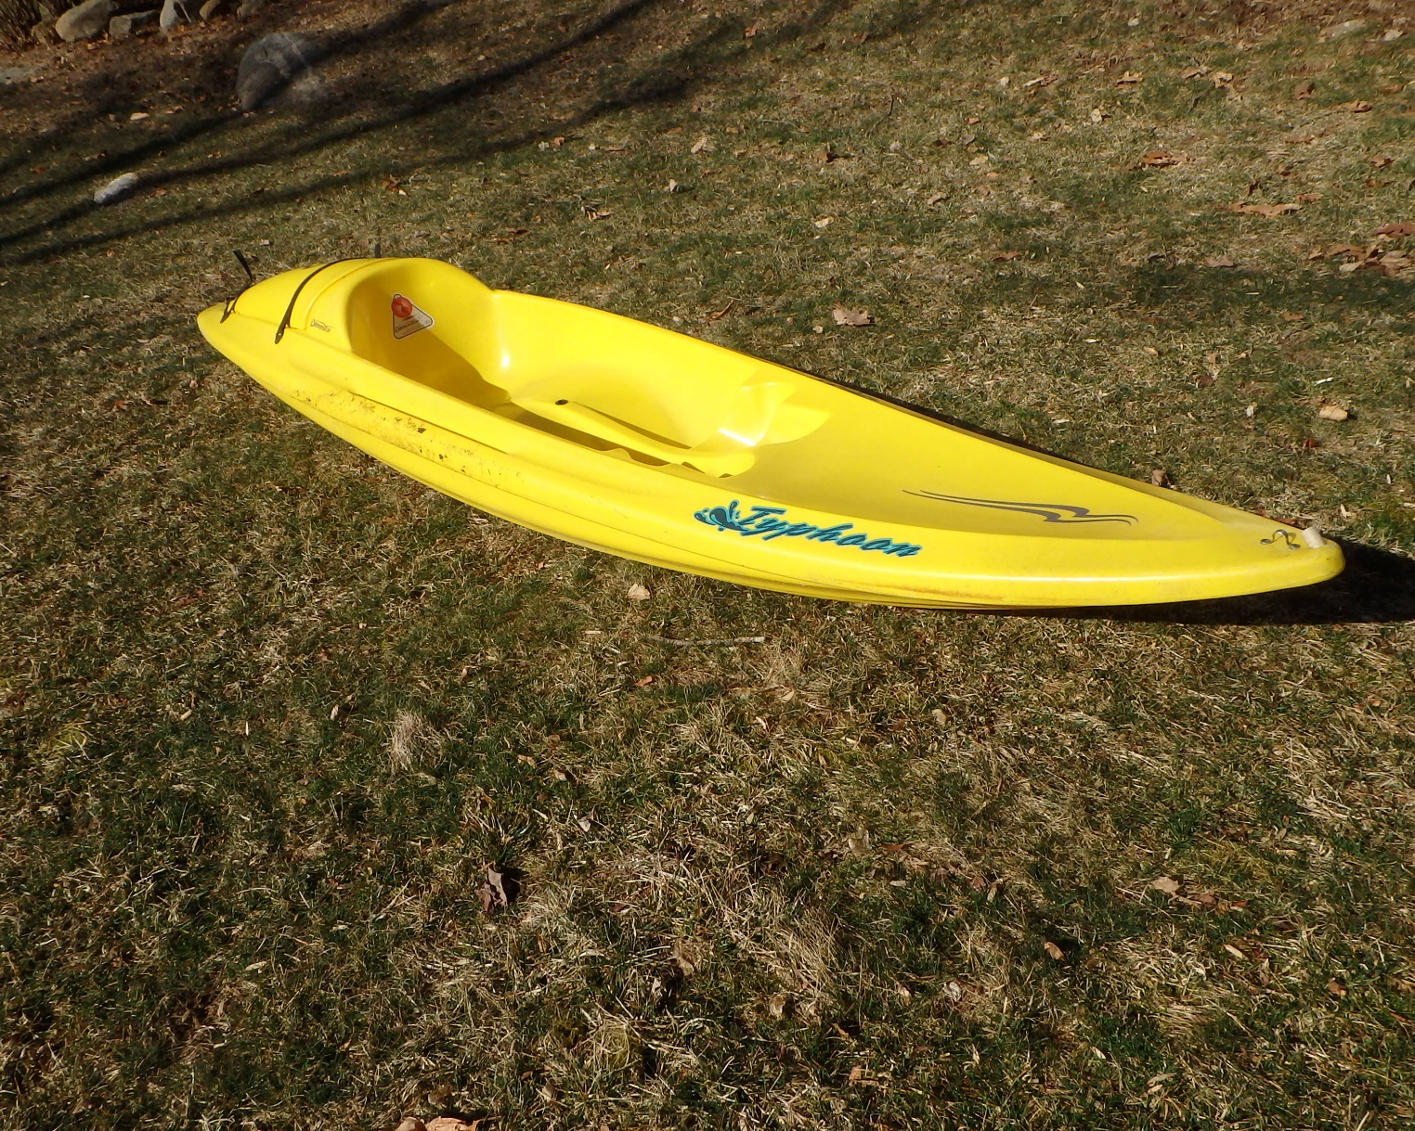

Fusion 124 Kayak. 10.6ft Yellow $200 (new price $100)

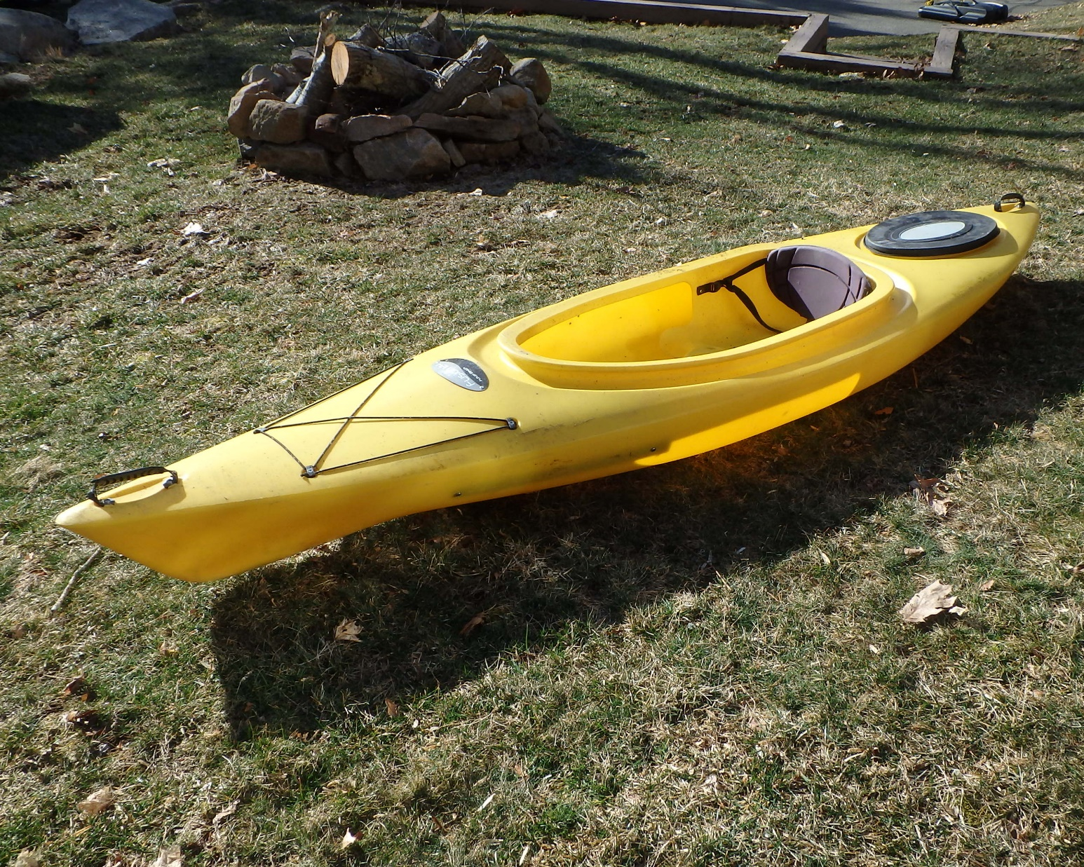

Old Town Otter Kayak 9ft Green $100 (sold)

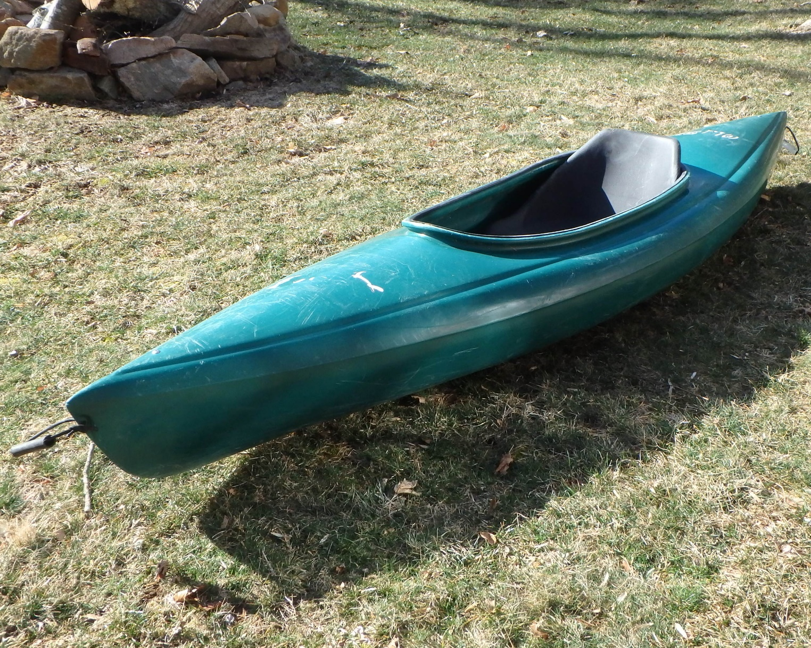

Old Town Otter Kayak 9.6ft Red $100 (sold)

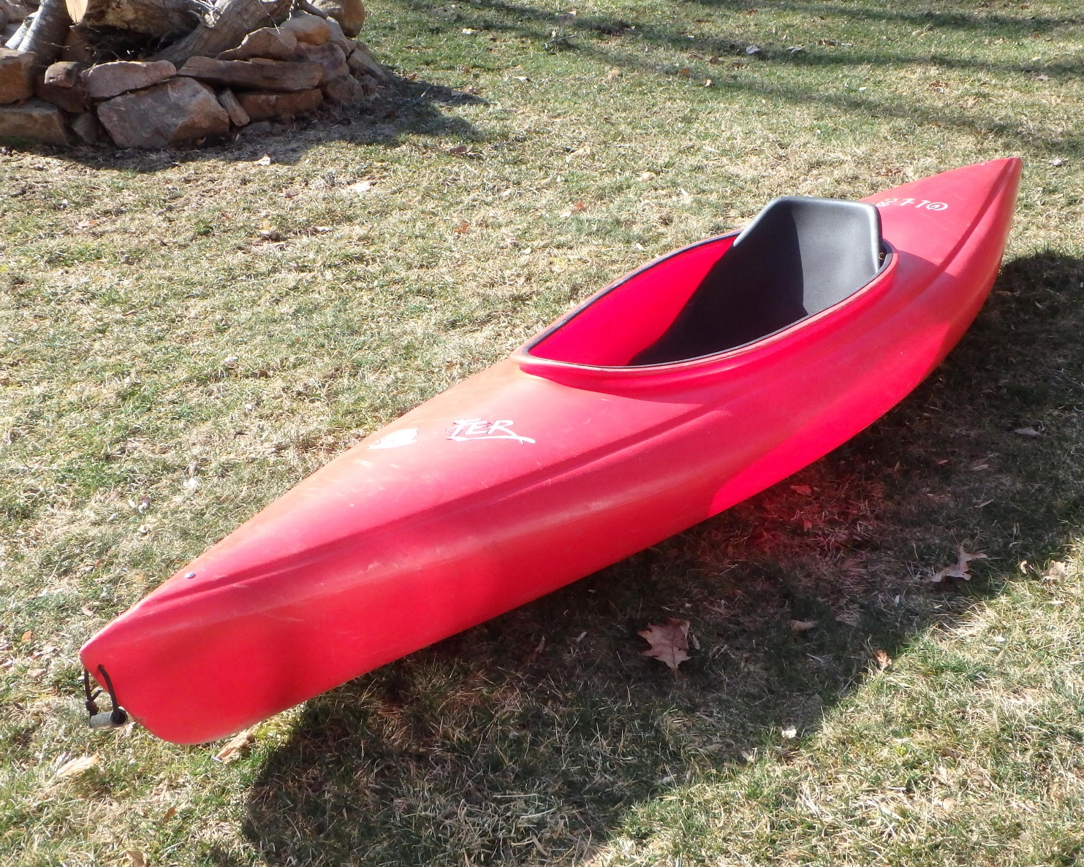

Elie Sound100 Kayak 10ft Red $250 (each) (sold)
Elie Sound100 Kayak 10ft Yellow $250 (each) (sold)

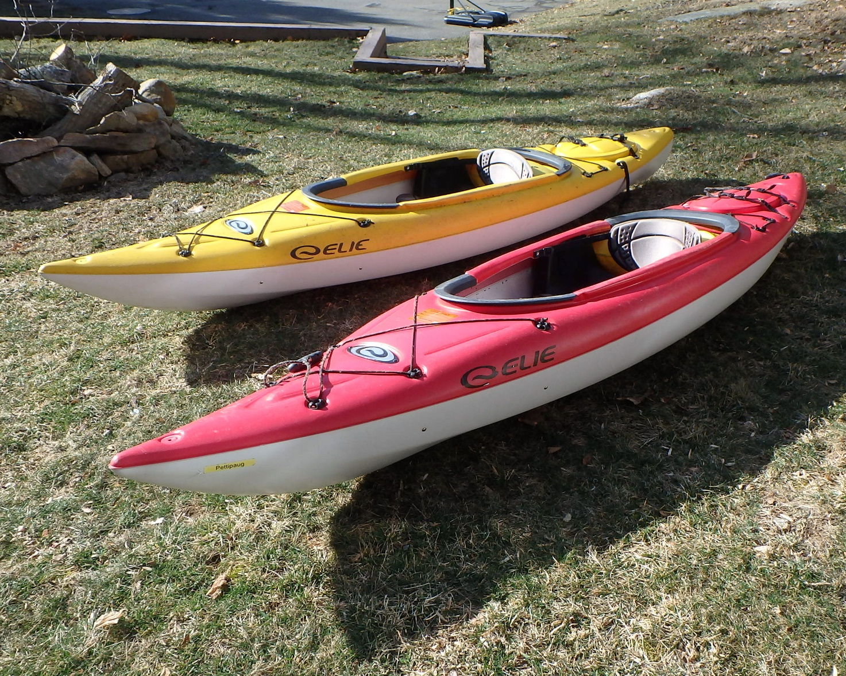

Old Town Millenium160 Kayak with rudder 16ft, 11” wide Burgundy $450 (sold)

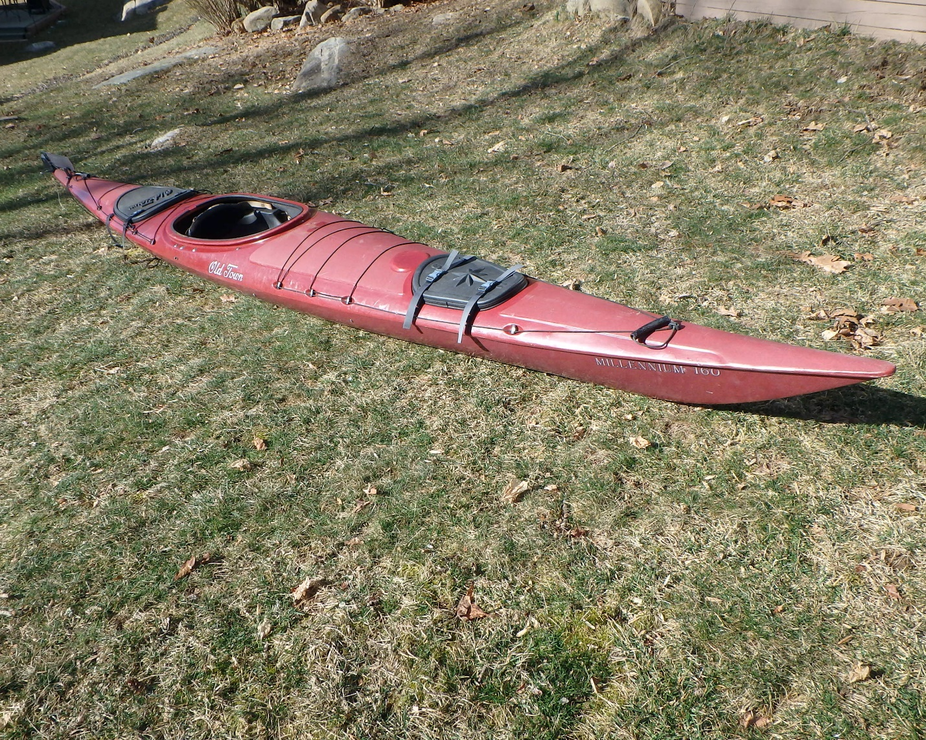

Perception Shadow Sea Lion Kayak with rudder 17 fet, 10” wide Red/orange $300 (new price $200)

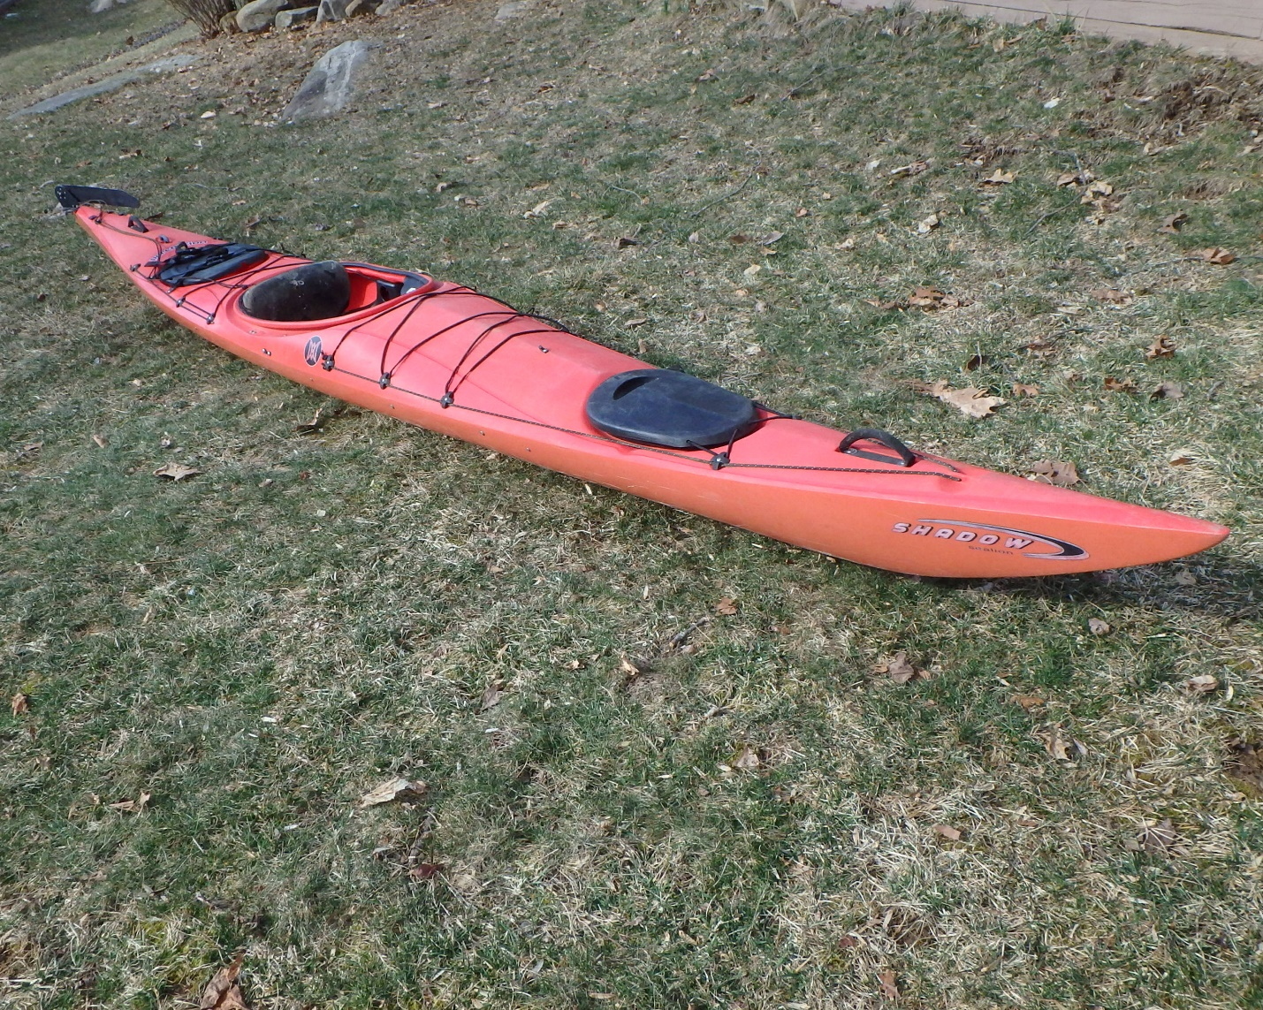

Wilderness Systems Sealution II Kayak with rudder 17ft 10” wide Teal $250 (new price $175)
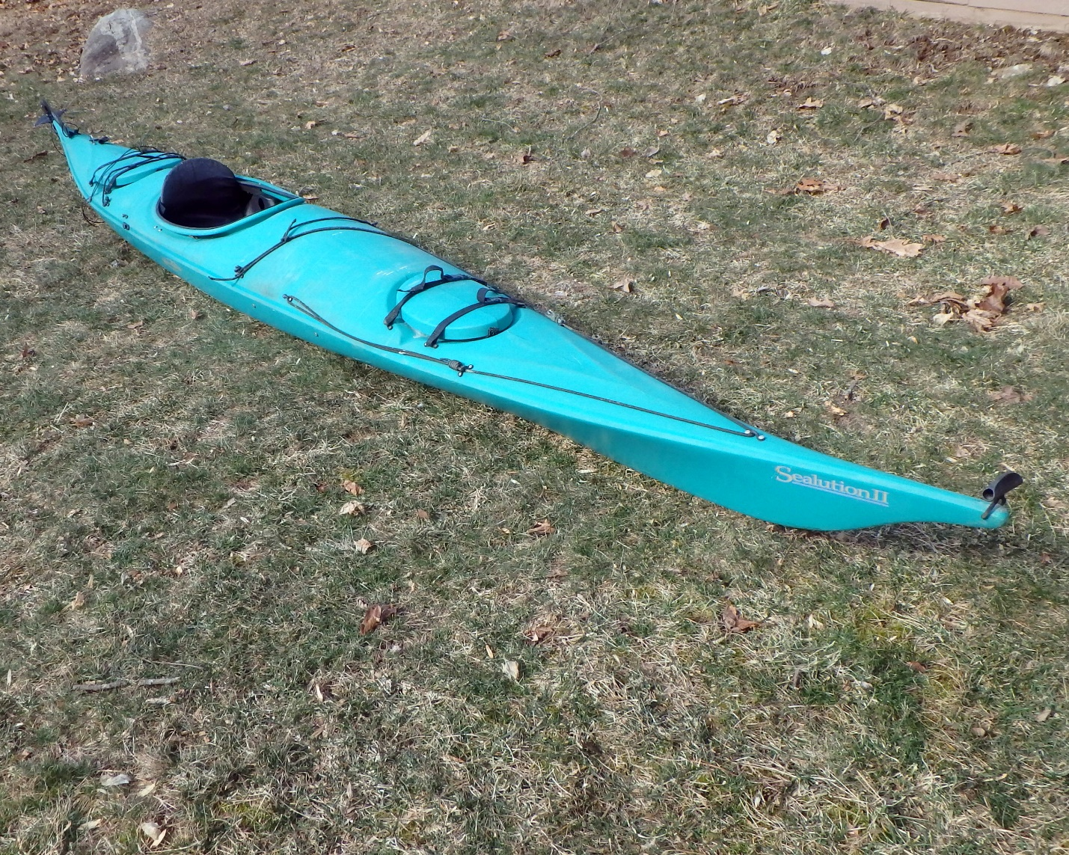

Old Town Penobscot 16 Canoe 16ft Green $400 (new price $275)
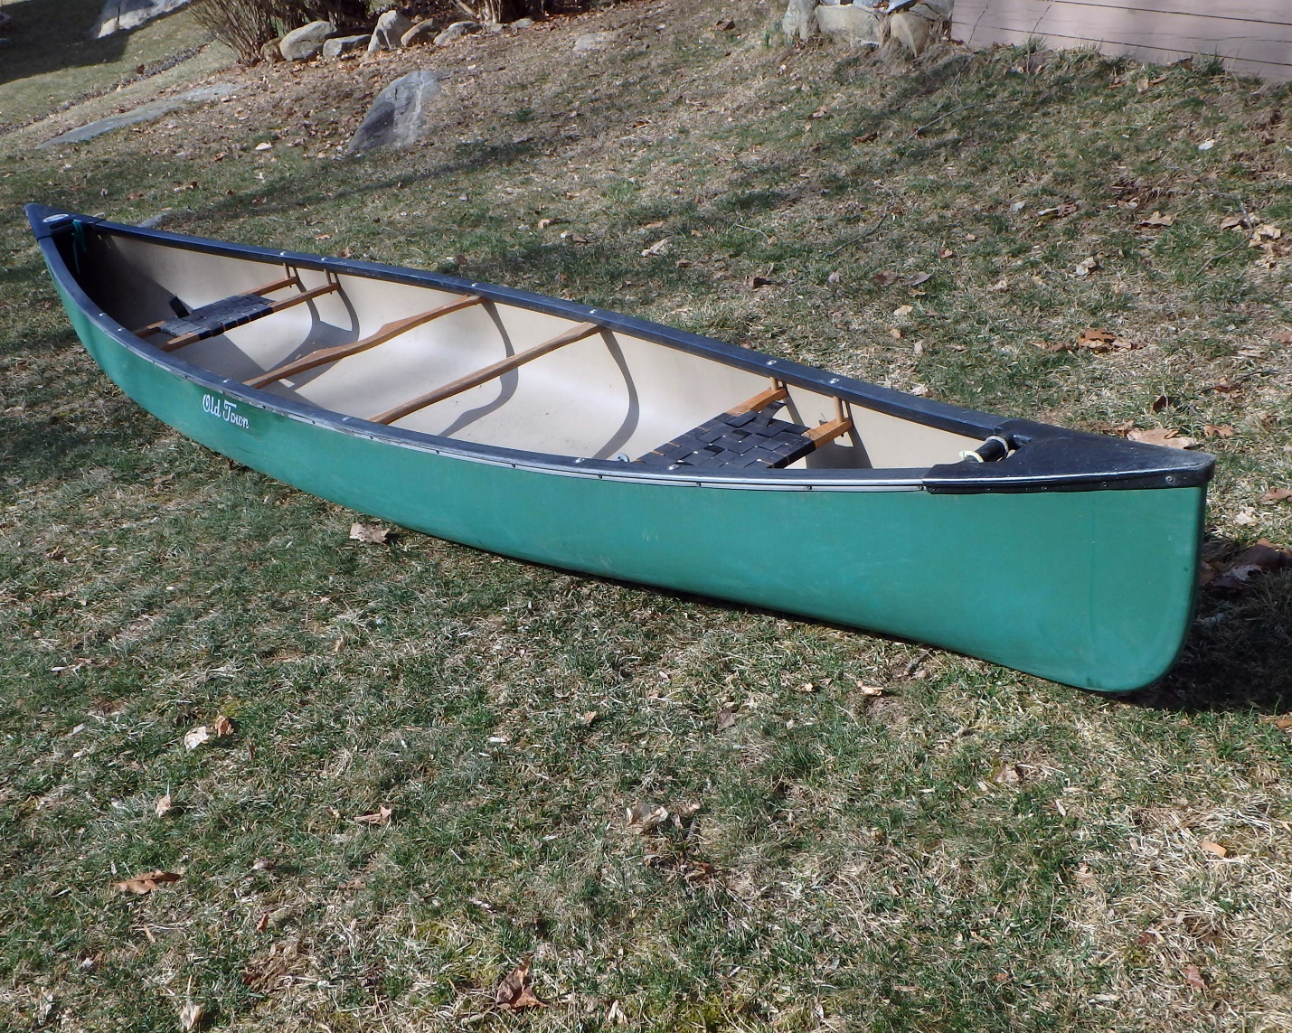

Native Watercraft Marvel14.5 double seat Kayak. Very good condition. 14.5ft Khaki $500 (sold)
