EYC Winter Speakers Series
Something for everyone!
Event starts at 5pm
Non-members attending will be asked to pay a $10 fee.
Both members and non-members will be invited to stay for dinner after the talks at a cost of $25 per person. Mark Borton
Tuesday, March 4th
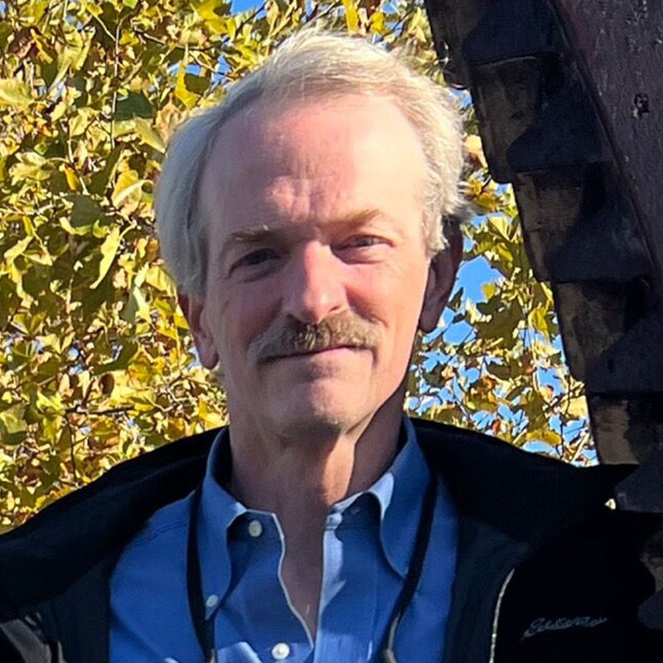
Mark Borton is a well-known non-fiction marine author. His work focusses on how to get here and where we might be going. His most recent work is Moondoggle: Franklin Roosevelt and the Fight for Tidal-Electric Power at Passamaquoddy (Fundy) Bay.

