PYC Reclaimed Kayaks
3-17-19

Wilderness Systems Cape Horn Kayak with rudder. 15ft. Yellow $350
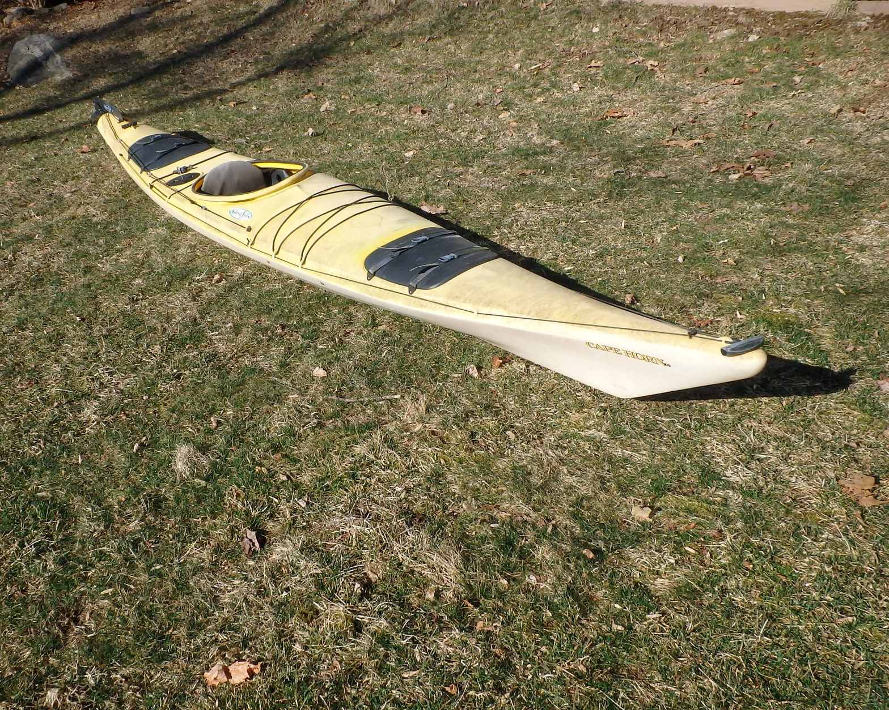

Dimension Typhoon Sit-on-Top Kayak. 11ft. Yellow $200

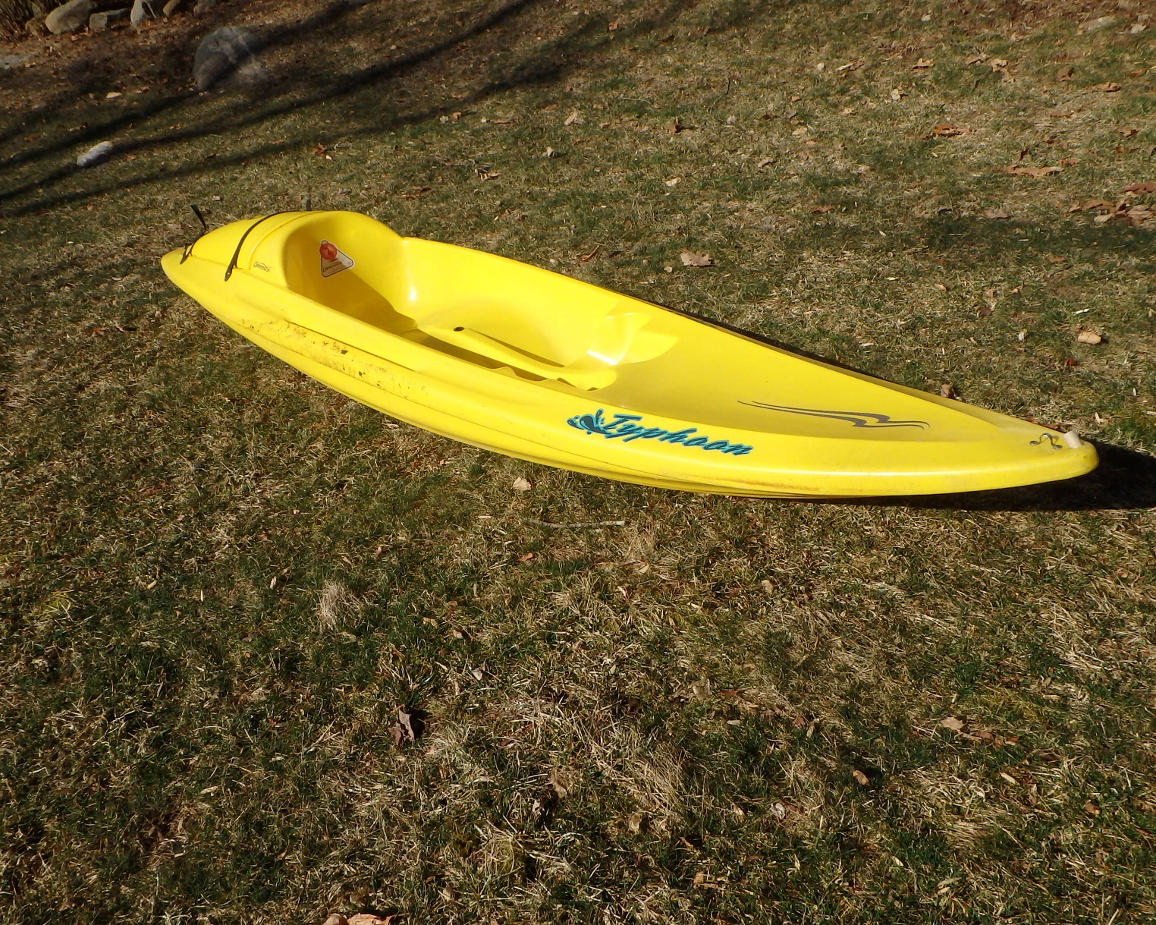

Fusion 124 Kayak. 10.6ft Yellow $200

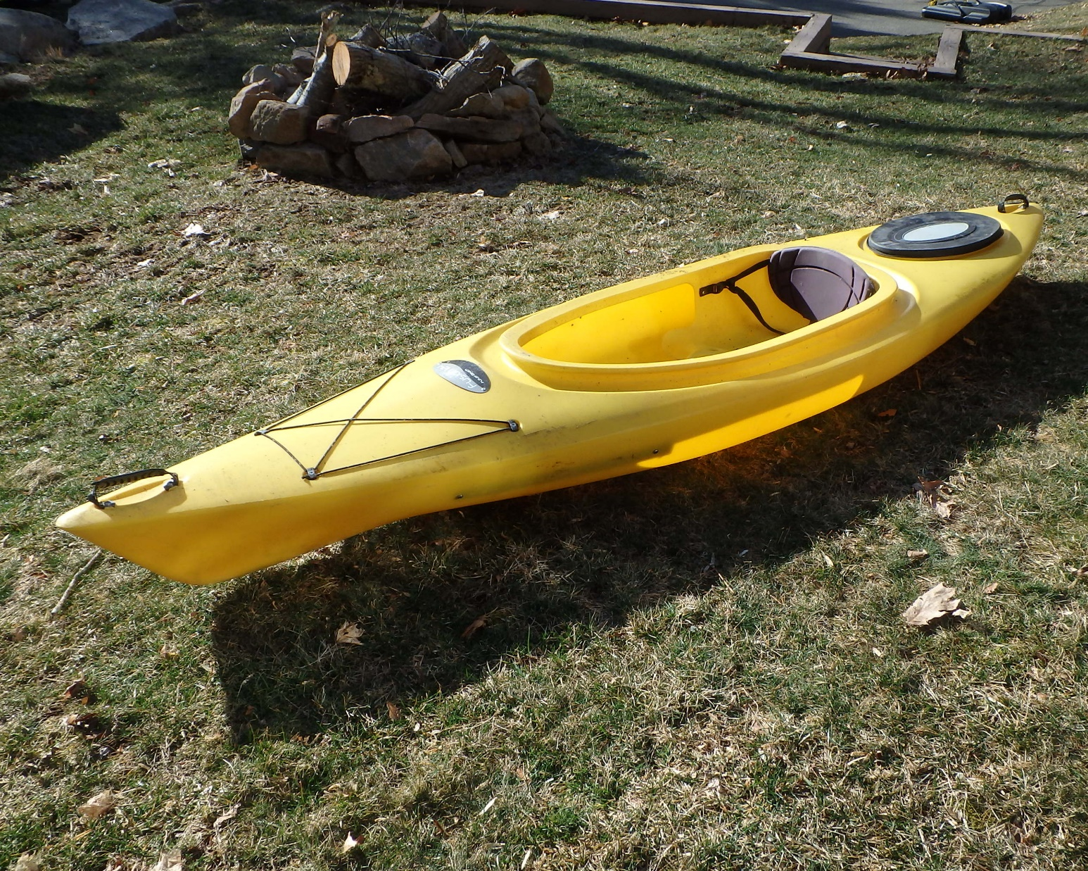

Old Town Otter Kayak 9ft Green $100

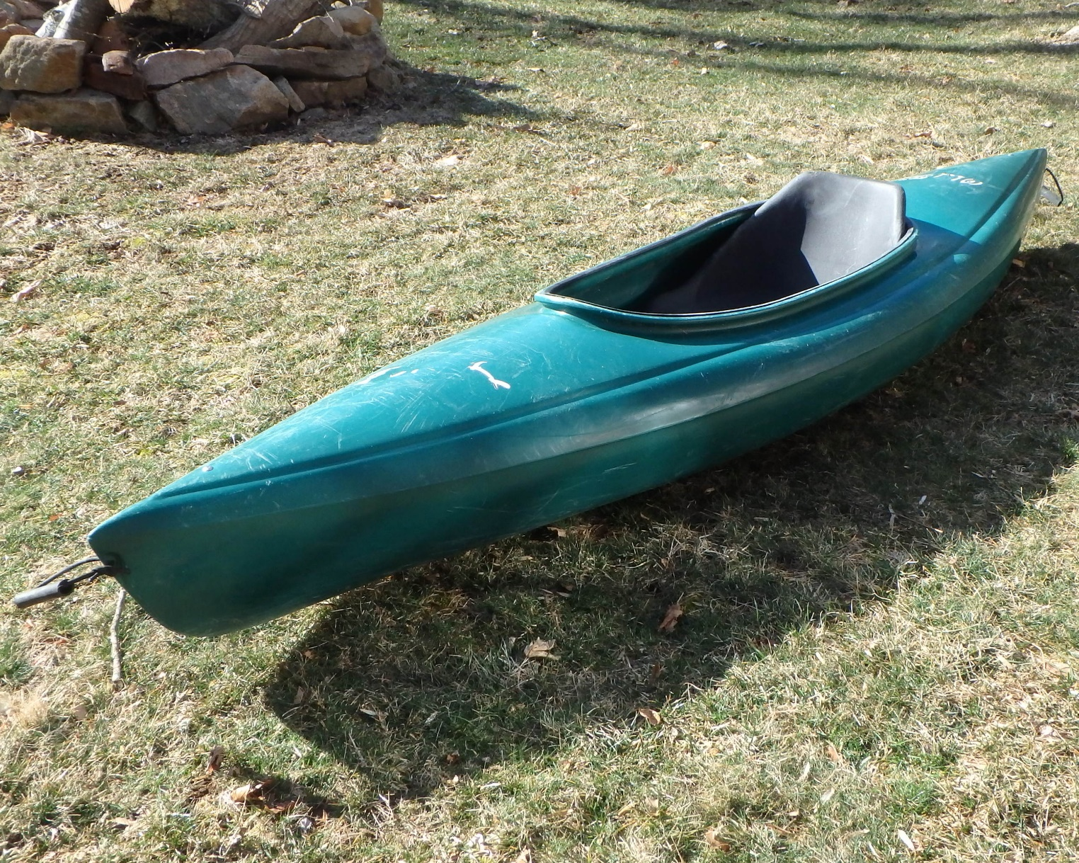

Old Town Otter Kayak 9.6ft Red $100

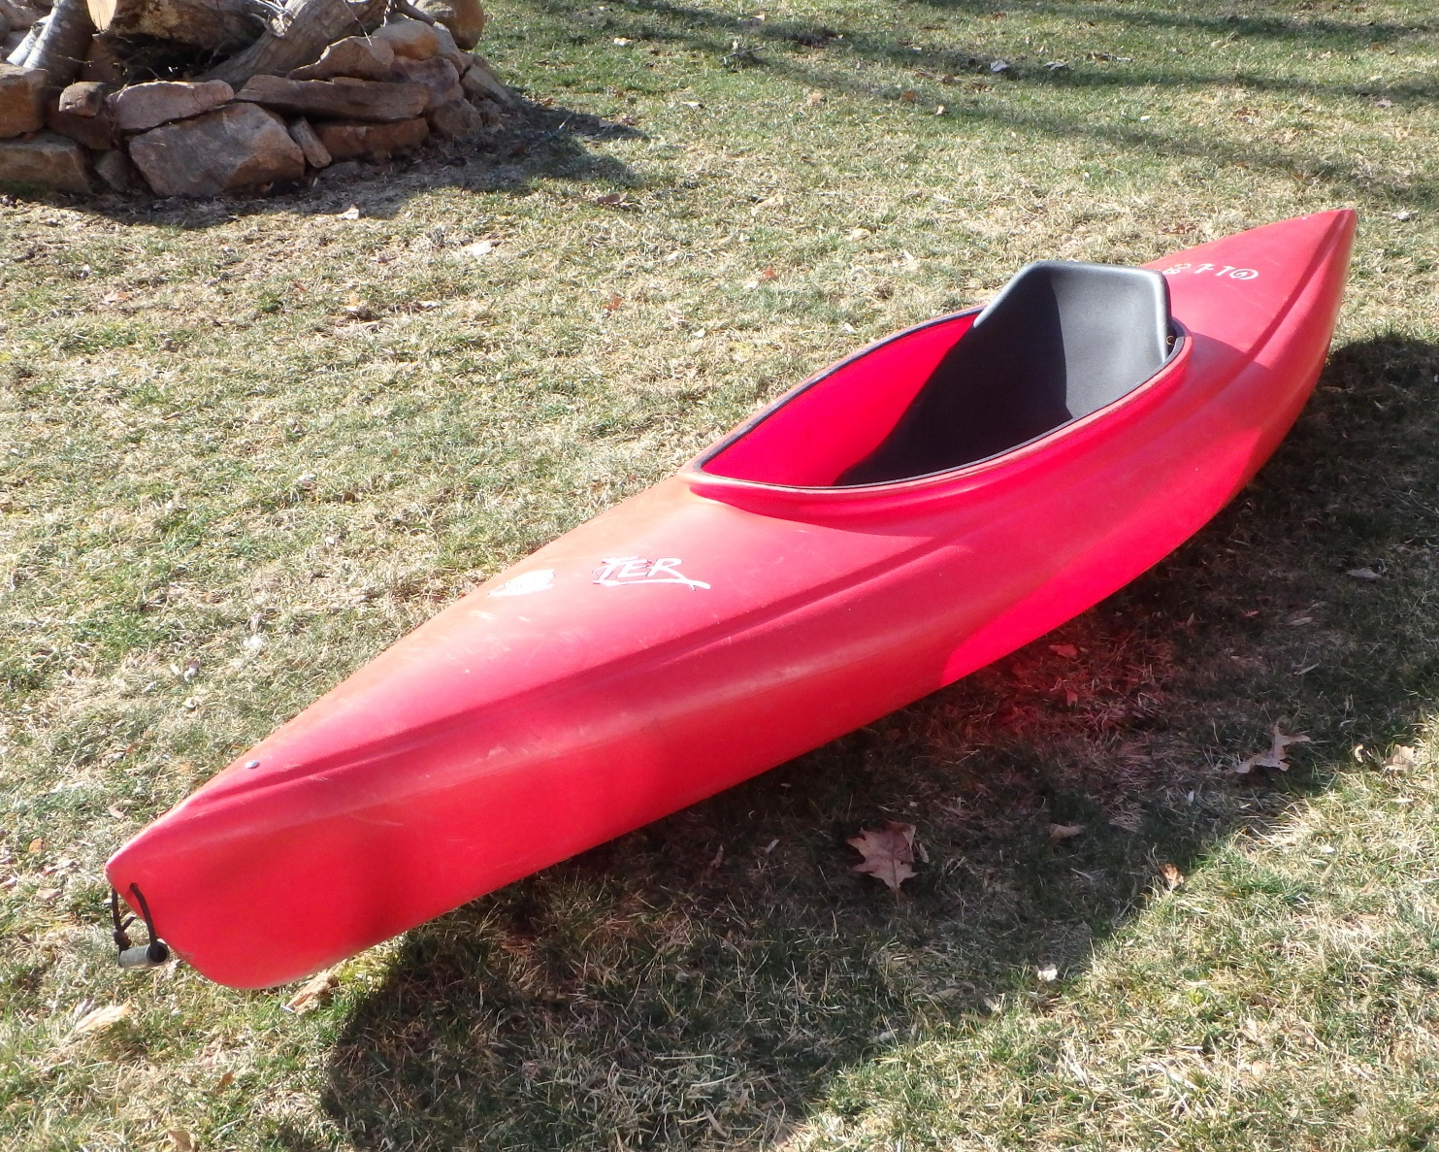

Elie Sound100 Kayak 10ft Red $250 (each)
Elie Sound100 Kayak 10ft Yellow $250 (each)

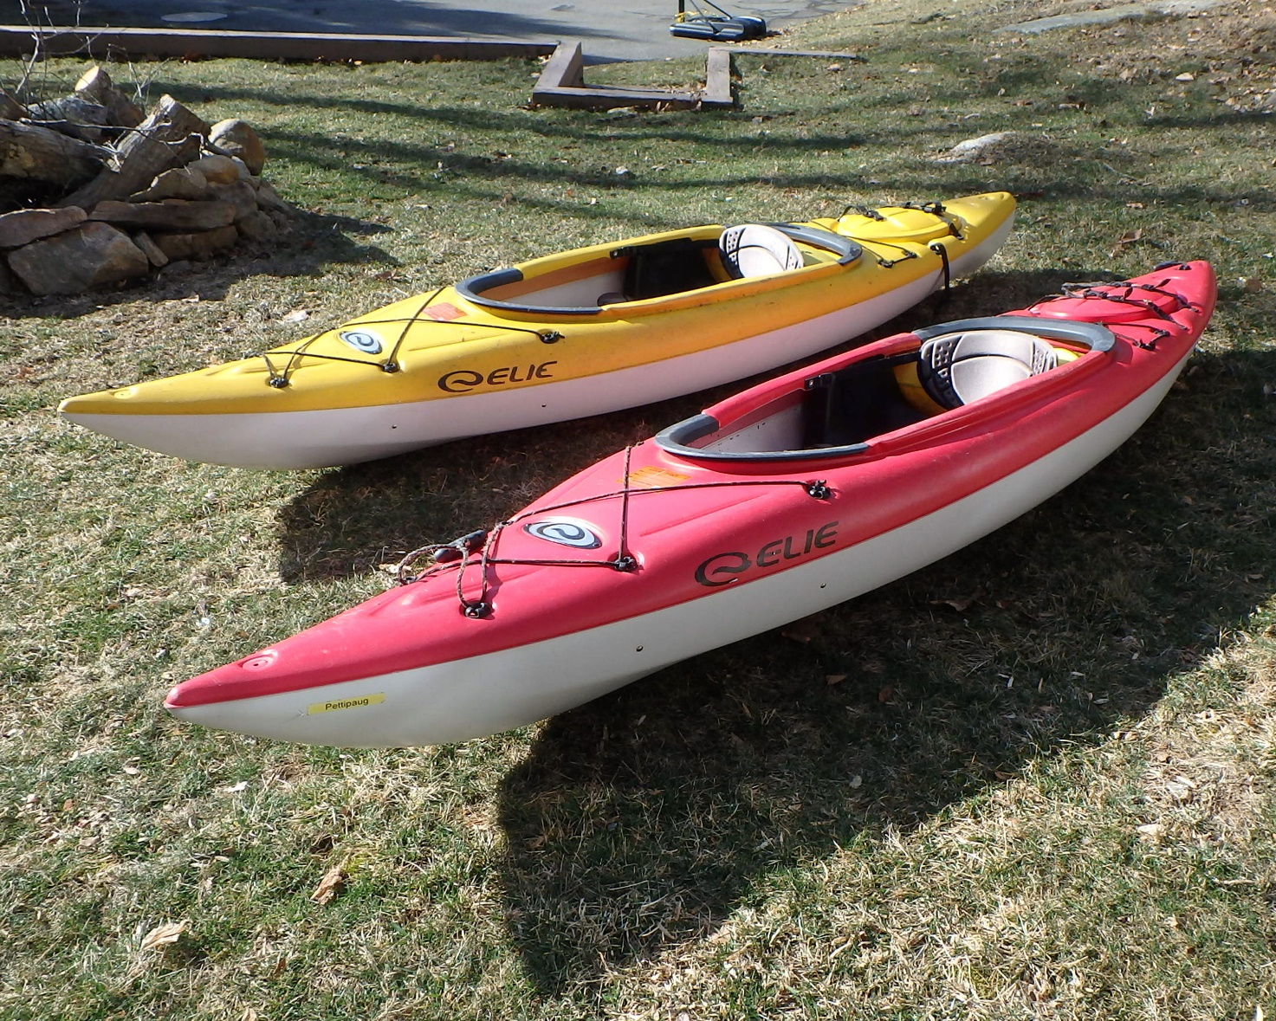

Old Town Millenium160 Kayak with rudder 16ft, 11” wide Burgundy $450

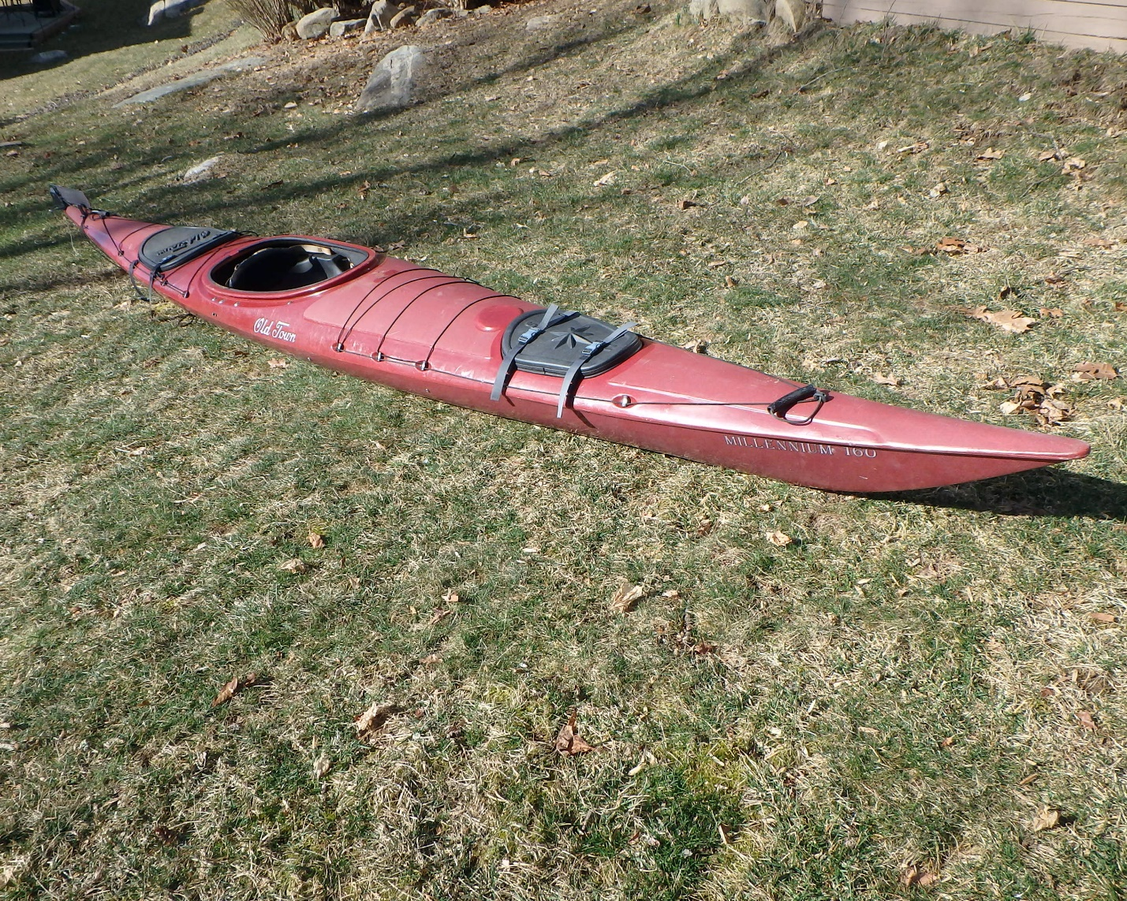

Perception Shadow Sea Lion Kayak with rudder 17 fet, 10” wide Red/orange $300

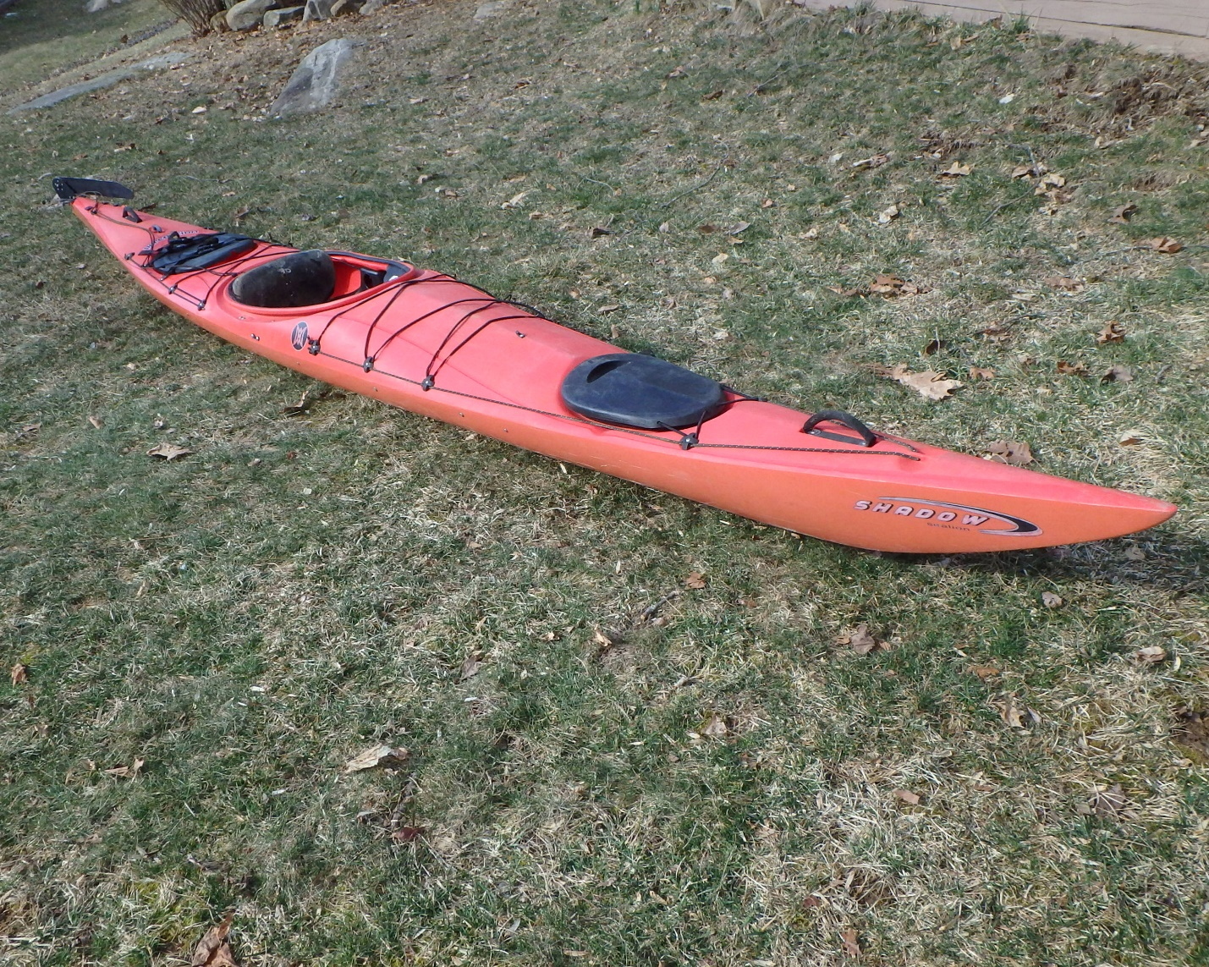

Wilderness Systems Sealution II Kayak with rudder 17ft 10” wide Teal $250
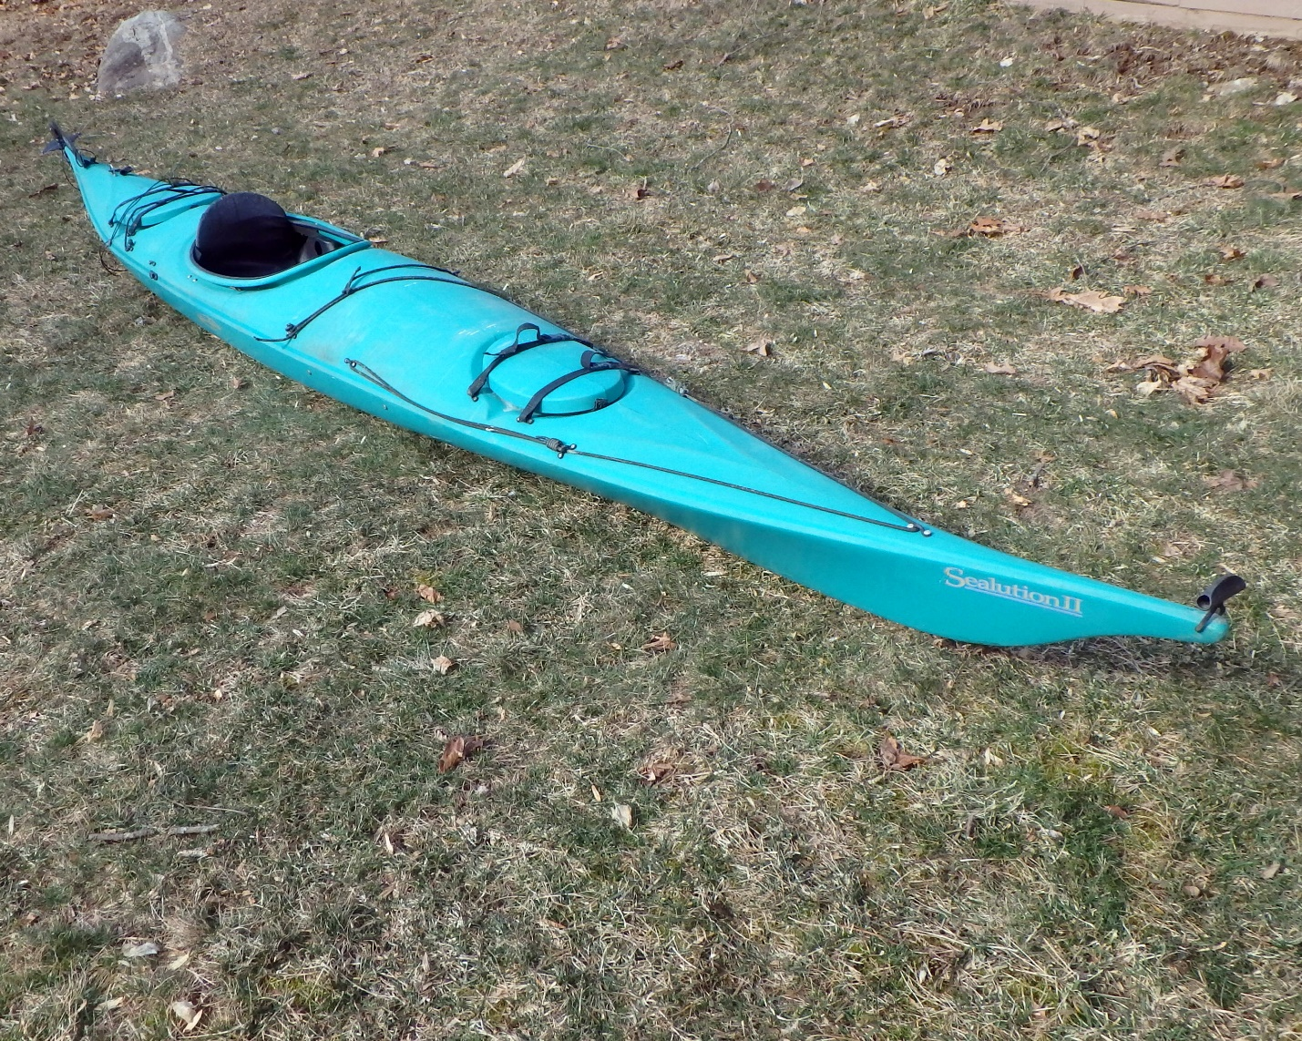

Old Town Penobscot 16 Canoe 16ft Green $400
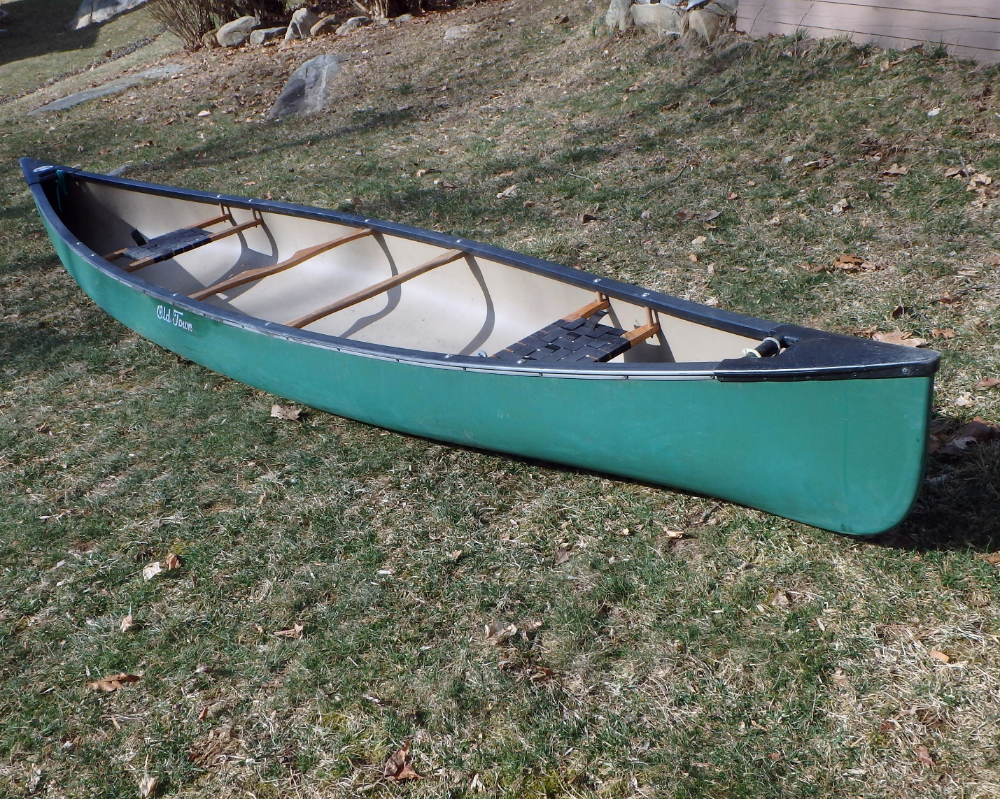

Native Watercraft Marvel14.5 double seat Kayak. Very good condition. 14.5ft Khaki $500
